Carole Chao

Professor Elio Bidinost

CART 360 A 2212

26 November 2021

Etude 4: StrangeDays

We are currently living in an era where society is always pushing the boundaries of technology and innovation. What was considered fiction a few decades ago is slowly becoming the reality. The evolution, refinement of designing methods and research allowed us to build prototypes of interactive artifacts using human-centered computing. Interspecies and human’s relationship with the environment will eventually impact our daily lives in the future.

Hence, I propose an interactive artifact that would be able to combine the characteristics of a living creature and build an artificial arm able to reach far distances using the characteristics of octopus’ tentacles. This prototype was highly inspired by modern action movie characters in relation to the theme of designing the enchanted future. It will essentially implement the octopus’ defense mechanism and chemical features to add sensors that mimic their behavior. For instance, their ability to camouflage or to release a dark ink whenever they feel threatened. Fun fact, an octopus limb will still move for at least an hour after being detached from the body because it has its own network control system of 400,000 neurons[1]!

Moreover, this prototype can be carried in a bag or attached to the body of the user with strings. Another benefit it can provide is the ability to complete out of reach tasks that requires a certain height or is at a distance. The claws at the end of the artificial arm will allow the user to collect light objects or creatures and bring them closer to them with a retractable arm. The data collected will help humans have a better understanding of octopus’ survival instinct, their ability to detect danger with their senses and their self-defense reactions.

This prototype might as well, give us the answer as to how the octopuses are able to escape locked boxes as seen online and survive in the wild ocean amongst other predators. It could also be a useful self-defense tool in a post-pandemic society where crime rates are increasing or a tool allowing scientist to carry their experiments from a distance.

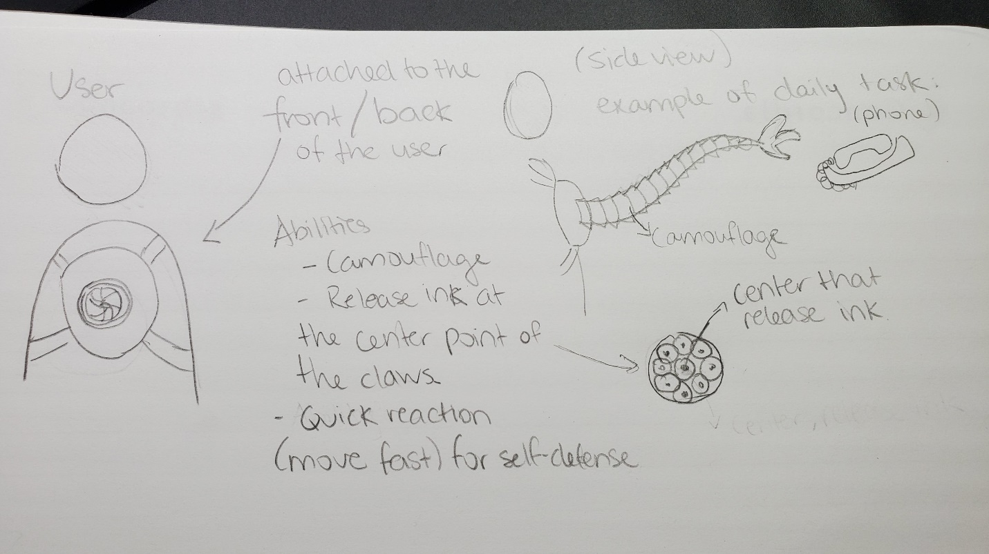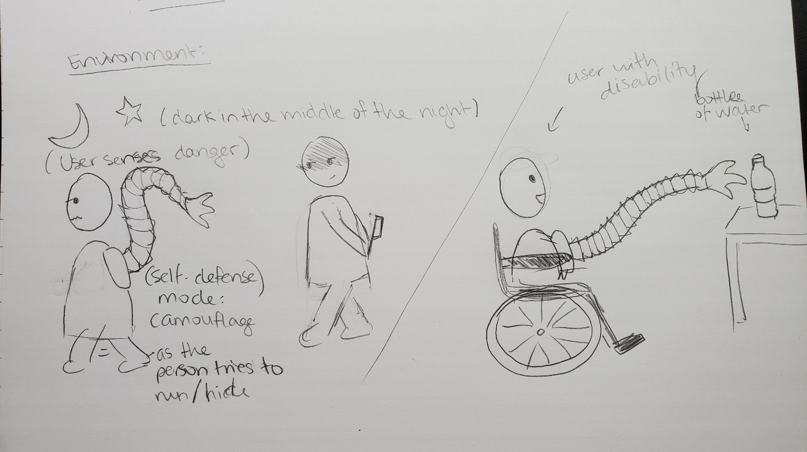

1. Yong, Ed. “Why Octopus Arms Don't Get Tangled.” *Science*, National Geographic, 3 May 2021, www.nationalgeographic.com/science/article/why-octopus-arms-dont-get-tangled. Accessed 25 Nov. 2021.